City of Phillips’ Common Council Meeting
Council Room, Municipal Hall
174 S Eyder Avenue
May 8, 2018
5:30 p.m.
Mayor, Charles Peterson
Council Members: Wards 1 & 2 –Richard Heitkemper, Jerry Clark; Ward 3 – John Vlach, Laura Tomaszewski; Ward 4 -Dorothy Hanish, John Klimowski.
Public Works – Jeff Williams; Water-Sewer - Todd Toelle Police – Michael Hauschild; Library – Rebecca Puhl
Clerk/Treasurer: Shelby Prochnow

This meeting is held in compliance with Wisconsin’s Open Meeting Law, WI § Chapter 19, Subchapter V. As such it is open to the public.

Call to Order (presiding officer)
Greeting
Certification of compliance with Open Meeting Law
Pledge of Allegiance

Roll Call: Charles Peterson ___, Jerry Clark___, Richard Heitkemper ___, Laura Tomaszewski, ___ John Vlach___, Dorothy Hanish ___, John Klimowski___.

Public Comment
DISCUSSION-ACTION ITEMS:

- Motion to approve April 13, 2018 Council & Organizational Meeting Minutes.

- Motion to approve the payment of vouchers in total amount of $xxxxxxx.

- Motion to approve a Capital Project fund to be created as recommended by the Committee of the Whole.

- Motion to authorize the signing of the Sign Easement.

- Committee Reports:
Ambulance
Chamber

- Adjournment

COUNCIL PROCEEDINGS

………of the Common Council of the City of Phillips at a meeting held in the Council Room of Municipal Hall on May 8, 2018.

The meeting was called to order by Mayor Peterson at 5:30 p.m. Those present included:
Mayor Peterson
1st Aldermanic District: Jerry Clark
2nd Aldermanic District: Laura Tomaszewski, John Vlach
3rd Aldermanic District: Dorothy Hanish
Clerk/Treasurer: Shelby Prochnow
Also present: Jason Marvin and Lori Hanson

Public Comment: None
DISCUSSION-ACTION ITEMS:

- Clark/Vlach moved to approve April 17, 2018 Council & Organizational Meeting Minutes. Carried

- Tomaszewski/ Hanish moved to approve the payment of vouchers in total amount of $162,679.97. Carried

- Clark/Tomaszewski moved to approve a Capital Project fund to be created as recommended by the Committee of the Whole. Carried

- Vlach/ Clark moved to authorize the signing of the Sign Easement. Carried

- Committee Reports:
Ambulance: Next meeting is July 25th. They are not able to get gas from the County anymore, so they will be getting it commercially, so the prices will go up.

Library: Becky was in Pewaukee for library training that went well. Doing school visits right now and the kick off party is June 6th at the Armory.

Chamber: Lori Hanson from the chamber came to ask if the City would contribute half the cost, $250, for the flowers for the downtown planters that they get from Winter Greenhouse. Also, the building outside is deteriorating and if they do not repair it there will be dry rot. Who owns the building was in question as they try to determine the cost of the repair. Both items, the flowers and exterior, will be placed on the June Committee of the Whole agenda. Vlach reported that the Chamber received a letter from the county will be doing away with the tourism department.

- Vlach/ Hanish moved from adjournment. Time 5:50pm.
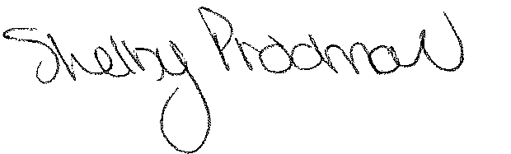
Shelby Prochnow
Clerk/Treasurer

