City of Phillips’ Common Council Meeting
Council Room, Municipal Hall
174 S Eyder Avenue
March 13, 2018
5:30 p.m.
Mayor, Charles Peterson
Council Members: Wards 1 & 2 –Richard Heitkemper, Jerry Clark; Ward 3 – John Vlach, Laura Tomaszewski; Ward 4 -Dorothy Hanish, John Klimowski.
Public Works – Jeff Williams; Water-Sewer - Todd Toelle Police – Michael Hauschild; Library – Rebecca Puhl
Clerk/Treasurer: Shelby Prochnow

This meeting is held in compliance with Wisconsin’s Open Meeting Law, WI § Chapter 19, Subchapter V. As such it is open to the public.

Call to Order (presiding officer)
Greeting
Certification of compliance with Open Meeting Law
Pledge of Allegiance

Roll Call: Charles Peterson ___, Jerry Clark___, Richard Heitkemper ___, Laura Tomaszewski, ___ John Vlach___, Dorothy Hanish ___, John Klimowski___.

Public Comment
DISCUSSION-ACTION ITEMS:

- Motion to approve March 13, 2018 Council Meeting Minutes.

- Motion to approve the payment of vouchers in total amount of $480,248.81.

- Motion to approve Change Order #1 from Staab Construction as recommended by the Committee of the Whole.

- Motion to approve Pay Request #8 for Staab Construction in the amount of $14,168.38 as recommended by the Committee of the Whole.

- Committee Reports:
Ambulance
Chamber

- Adjournment

COUNCIL PROCEEDINGS- UNOFFICIAL

………of the Common Council of the City of Phillips at a meeting held in the Council Room of Municipal Hall on April 17, 2018.

The meeting was called to order by Mayor Peterson at 5:30 p.m. Those present included:
Mayor Peterson
1st Aldermanic District: Jerry Clark, Richard Heitkemper
2nd Aldermanic District: Laura Tomaszewski, John Vlach
3rd Aldermanic District: Dorothy Hanish, John Klimowski
Clerk/Treasurer: Shelby Prochnow
Also present: Anna Marie Hansen

Public Comment: None
DISCUSSION-ACTION ITEMS:

- Hanish/ Tomaszewski moved to approve March 13, 2018 Council Meeting Minutes. Carried.

- Klimowski/ Clark moved to approve the payment of vouchers in total amount of $480,248.81. Carried

- Heitkemper/ Klimowski moved to approve Change Order #1 from Staab Construction as recommended by the Committee of the Whole. Carried

- Heitkemper/ Vlach moved to approve Pay Request #8 for Staab Construction in the amount of $14,168.38 as recommended by the Committee of the Whole. Carried

- Committee Reports:
Ambulance: Next meeting is April 25th at 6:30pm. Everything is going fine.

Chamber: Working on getting new members and getting ready for the business before 5 and after 5 events.

- Klimowski/ Clark moved to adjourn at 5:35pm.

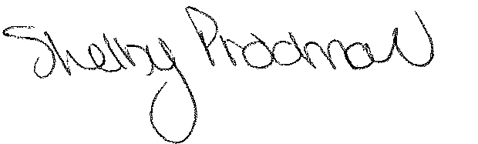
Shelby Prochnow
Clerk/Treasurer

