City of Phillips’
Common Council Organizational Meeting
Council Room, Municipal Hall
174 S Eyder Avenue
April 17, 2018
5:30 p.m. – Directly following Common Council Meeting

Mayor, Charles Peterson
Council Members: Wards 1 & 2 –Richard Heitkemper, Jerry Clark; Ward 3 – John Vlach, Laura Tomaszewski; Ward 4 -Dorothy Hanish, John Klimowski.
Public Works – Jeff Williams, Water-Sewer - Todd Toelle, Police – Michael Hauschild; Library – Rebecca Smith
Clerk/Treasurer: Shelby Prochnow

Oaths of Office:
Mayor – Charles Peterson
At Large – John Vlach
At Large – John Klimowski
At Large – Jerry Clark
Ward 4 – Dorothy Hanish

This meeting is held in compliance with Wisconsin’s Open Meeting Law, WI § Chapter 19, Subchapter V. As such it is open to the public.

Call to Order (presiding officer)
Greeting
Certification of compliance with Open Meeting Law
Pledge of Allegiance

Roll Call: Charles Peterson ___, Jerry Clark___, Richard Heitkemper ___, Laura Tomaszewski ___, John Vlach___, Dorothy Hanish ___, John Klimowski___.

Public Comment
DISCUSSION-ACTION ITEMS:

- Nomination/Election of position of President, Common Council

- Presentation of Committee appointments.

- Adjournment

COUNCIL PROCEEDINGS- UNOFFICIAL

………of the Common Council of the City of Phillips at a meeting held in the Council Room of Municipal Hall on April 17, 2018.

Oaths of Office were given for the following officials:
Alderperson At-large: Jerry Clark
Alderperson At-large: John Vlach
Alderperson At-large: John Klimowski
Ward 4 (District 3): Dorothy Hanish
Mayor: Charles Peterson

The meeting was called to order by Mayor Peterson at 5:35 p.m. Those present included:
Mayor Peterson
1st Aldermanic District: Jerry Clark, Richard Heitkemper
2nd Aldermanic District: Laura Tomaszewski, John Vlach
3rd Aldermanic District: Dorothy Hanish, John Klimowski
Clerk/Treasurer: Shelby Prochnow
Also present: Anna Marie Hansen

Public Comment: None
DISCUSSION-ACTION ITEMS:

- Nomination/Election of position of President, Common Council: Heitkemper/ Vlach nominated Jerry Clark for President of the Common Council. Klimowski/ Hanish moved to close the nominations and cast a unanimous ballot to vote Jerry Clark as the President of the Common Council.

- Presentation of Committee appointments: Committee’s will remain the same as last year. Laura Tomaszewski will be the alternate for Chamber meetings.

- Clark/ Klimowski moved to adjourn at 5:41pm.

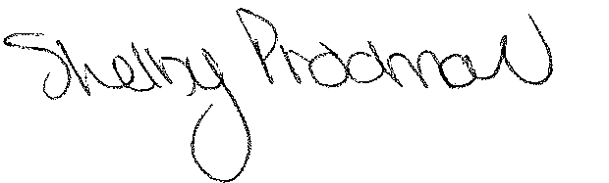
Shelby Prochnow
Clerk/Treasurer

