City of Phillips’ Common Council
Special Meeting
Council Room, Municipal Hall
174 S Eyder Avenue
September 28, 2017
5:30 p.m.

Mayor, Charles Peterson
Council Members: Wards 1 & 2 –Richard Heitkemper, Jerry Clark; Ward 3 – John Vlach, Laura Tomaszewski; Ward 4 -Dorothy Hanish, John Klimowski.
Public Works – Jeff Williams; Water-Sewer - Todd Toelle Police – Michael Hauschild; Library – Rebecca Smith
Clerk/Treasurer: Barb Revak

This meeting is held in compliance with Wisconsin’s Open Meeting Law, WI § Chapter 19, Subchapter V. As such it is open to the public.

Call to Order (presiding officer)
Greeting
Certification of compliance with Open Meeting Law
Pledge of Allegiance

Roll Call: Charles Peterson ___, Jerry Clark___, Richard Heitkemper ___, Laura Tomaszewski, ___ John Vlach___, Dorothy Hanish ___, John Klimowski___.

Public Comment

DISCUSSION-ACTION ITEMS:

- Motion to determine Clerk/Treasurer Barb Revak’s replacement.

- Adjournment

COUNCIL PROCEEDINGS

………of the Common Council of the City of Phillips at a meeting held in the Council Room of Municipal Hall on September 28, 2017.

The meeting was called to order by Mayor Peterson at 5:30 p.m. Those present included:
Mayor Peterson
1st Aldermanic District: Jerry Clark, Richard Heitkemper
2nd Aldermanic District: Laura Tomaszewski, John Vlach-absent
3rd Aldermanic District: Dorothy Hanish -Absent, John Klimowski
Clerk/Treasurer: Barbara Revak
Also present: Michael Hauschild, Jeff Williams, Todd Toelle, Jeff Rominske, Mike Longfield and Jim Pisca.
Public Comment: None
DISCUSSION-ACTION ITEMS:

- Motion to determine Clerk/Treasurer Barb Revak’s replacement: Clerk/Treasurer Revak read the below recommendation.
- My first highly recommended option would be for the City of Phillips to promote Shelby Prochnow to Clerk/Treasurer and increase her wages to a fair salary. Advertise for a part-time, Deputy Clerk/Treasurer (approx. 20 hours). Shelby would determine the scheduling.
- My second recommendation would be to promote Shelby Prochnow to Clerk/Treasurer with a 6-month probationary period. Advertise for a temporary 6-month office assistant.
At the end of the probationary period, if things are working out, Shelby continues in her position as the new Clerk/Treasurer for the City of Phillips. If either the City of Phillips or Shelby Prochnow are not happy with the duties or the performance, Shelby Prochnow shall be allowed to return to her previous position of Deputy Clerk/Treasurer. The City would then advertise for a Clerk/Treasurer.
If Shelby Prochnow becomes the new Clerk/Treasurer then the City of Phillips would have the option of either making the temporary 6-month office assistant the new Deputy/Clerk Treasurer or advertise for someone else.
City department heads and employees all recommended the Council promote Shelby Prochnow to Clerk/Treasurer after Barb retires. Mayor Peterson stated he believes in promoting from within. He stated that she already has 2 years of experience with the City of Phillips and a bachelor’s degree in accounting which she earned while holding down 3 jobs. Richard Heitkemper agreed and stated that Shelby Prochnow was hired with the hopes of her becoming the next Clerk/Treasurer.

John Klimowski/Dorothy Hanish motioned to promote Shelby Prochnow to Clerk/Treasurer after Barb Revak retires with Barbs 2nd recommendation allowing her to return to her current position if things don’t work out. Roll Call vote: Clark-aye, Heitkemper-aye, Tomaszewski-aye, Vlach-absent, Hanish-aye and Klimowski – aye Carried.

Discussion of wages came next with Heitkemper recommending the department heads all stay close to the same wage.
Heitkemper/Klimowski motioned to offer Shelby Prochnow a reduced wage from Barb’s current wage of 10% with an increase in 6 months of 5% and full wage on 1/1/2019.
Roll Call vote: Clark-aye, Heitkemper-aye, Tomaszewski-aye, Vlach-absent, Hanish-nay and Klimowski – aye Carried.

Shelby Prochnow was offered the position of Clerk/Treasurer to start upon the retirement of Barb Revak on January 15, 2018. Shelby Prochnow accepted the postion.

- Clark/ Klimowski motioned to adjourn at 5:40pm.
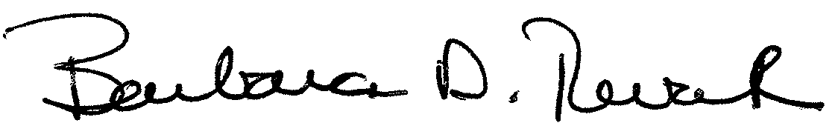

Barbara D. Revak
Clerk/Treasurer

