City of Phillips’ Common Council Meeting
Council Room, Municipal Hall
174 S Eyder Avenue
September 12, 2017
5:30 p.m.

Mayor, Charles Peterson
Council Members: Wards 1 & 2 –Richard Heitkemper, Jerry Clark; Ward 3 – John Vlach, Laura Tomaszewski; Ward 4 -Dorothy Hanish, John Klimowski.
Public Works – Jeff Williams; Water-Sewer - Todd Toelle Police – Michael Hauschild; Library – Rebecca Smith
Clerk/Treasurer: Barb Revak

This meeting is held in compliance with Wisconsin’s Open Meeting Law, WI § Chapter 19, Subchapter V. As such it is open to the public.

Call to Order (presiding officer)
Greeting
Certification of compliance with Open Meeting Law
Pledge of Allegiance

Roll Call: Charles Peterson ___, Jerry Clark___, Richard Heitkemper ___, Laura Tomaszewski, ___ John Vlach___, Dorothy Hanish ___, John Klimowski___.

Public Comment
DISCUSSION-ACTION ITEMS:

- Motion to approve August 8 and August 17, 2017 Council Meeting Minutes.

- Motion to approve the payment of vouchers in total amount of $1,729,194.37.

- Motion to accept results on the official Garbage/Recycling Survey for garbage pick-up as recommended by the Committee of the Whole.

- Motion to move forward with the recognition plaque with the choice being Elk Lake Park option #1 and Chain-O-Lakes Campground option #2 as recommended by the Committee of the Whole.

- Committee Reports:
Ambulance
Library
Chamber

- Adjournment

COUNCIL PROCEEDINGS

………of the Common Council of the City of Phillips at a meeting held in the Council Room of Municipal Hall on September 12, 2017.

The meeting was called to order by Mayor Peterson at 5:30 p.m. Those present included:
Mayor Peterson
1st Aldermanic District: Jerry Clark, Richard Heitkemper
2nd Aldermanic District: Laura Tomaszewski, John Vlach
3rd Aldermanic District: Dorothy Hanish -Absent, John Klimowski
Deputy Clerk/Treasurer: Shelby Prochnow
Also present: Becky Smith.
Public Comment: None
DISCUSSION-ACTION ITEMS:

- Tomaszewski/ Clark motioned to approve August 8 and August 17, 2017 Council Meeting Minutes. Carried

- Heitkemper/ Klimowski motioned to approve the payment of vouchers in total amount of $1,729,194.37. Carried

- Vlach/ Klimowski motioned to accept results on the official Garbage/Recycling Survey for garbage pick-up as recommended by the Committee of the Whole. Carried

- Heitkemper/ Tomaszewski motioned to move forward with the recognition plaque with the choice being Elk Lake Park option #1 and Chain-O-Lakes Campground option #2 as recommended by the Committee of the Whole. Carried

- Committee Reports:
Ambulance: Everything going good. Received their new automatic CPR machine for the ambulance.

Library: The 2017 Helen M. Heindl Summer Reading Program broke all previous records for book giveaways! Ages 0-18 yrs. old who turned in a weekly form after reading each week, picked out a free/brand new book to keep. Last year we gave away 603 books which was the highest number since we started the program. This year we gave away 995!!! 141 children participated. 18 children completed all 13 weeks

Chamber: Getting ready for Fall Festival. The banquet meeting is November 13th at 6:30pm at Red's Big Bear. They are working on getting a Price County bike trail going.

- Clark/ Klimowski motioned to adjourn at 5:46pm.

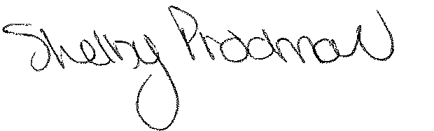
Shelby Prochnow
Deputy Clerk/Treasurer

