City of Phillips’ Common Council Special Meeting
Council Room, Municipal Hall
174 S Eyder Avenue
August 17, 2017
5:30 p.m.

Mayor, Charles Peterson
Council Members: Wards 1 & 2 –Richard Heitkemper, Jerry Clark; Ward 3 – John Vlach, Laura Tomaszewski; Ward 4 -Dorothy Hanish, John Klimowski.
Public Works – Jeff Williams; Water-Sewer - Todd Toelle Police – Michael Hauschild; Library – Rebecca Smith
Clerk/Treasurer: Barb Revak

This meeting is held in compliance with Wisconsin’s Open Meeting Law, WI § Chapter 19, Subchapter V. As such it is open to the public.

Call to Order (presiding officer)
Greeting
Certification of compliance with Open Meeting Law
Pledge of Allegiance

Roll Call: Charles Peterson ___, Jerry Clark___, Richard Heitkemper ___, Laura Tomaszewski, ___ John Vlach___, Dorothy Hanish ___, John Klimowski___.

Public Comment
DISCUSSION-ACTION ITEMS:

- Motion awarding the Bid for South Airport Road resurfacing.

- Adjournment

COUNCIL PROCEEDINGS

………of the Common Council of the City of Phillips at a meeting held in the Council Room of Municipal Hall on August 17, 2017.

The meeting was called to order by Mayor Peterson at 5:46 p.m. Those present included:

Mayor Peterson - Absent
1st Aldermanic District: Jerry Clark, Richard Heitkemper
2nd Aldermanic District: Laura Tomaszewski-Absent, John Vlach-Absent
3rd Aldermanic District: Dorothy Hanish, John Klimowski
Clerk/Treasurer: Barbara Revak

Also present: None

Public Comment: None

DISCUSSION-ACTION ITEMS:

- Klimowski/Heitkemper motioned to award the bid for South Airport Road to American Asphalt for a bid of $422,021.10. Carried

- Hanish/Vlach motioned to adjourn at 6:21PM.

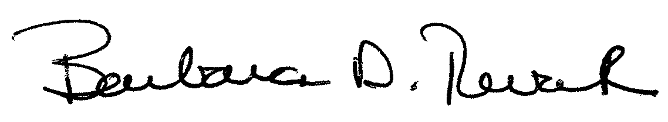
Barbara Revak
City Clerk/Treasurer

