City of Phillips
Regular Meeting of the Common Council
Council Room, Municipal Building
April 11, 2006 at 7:00 PM
AGENDA

Mayor Joseph S. Boho
Council Members: Ward 1 & 2 – Mark Chrouser, Jayson Reinke; Ward 3 & 4 - Linda Johnson, Charles Peterson; Ward 5 – Elvis Presley, Jeffrey Fahl.
City Attorney: Bruce Marshall
Public Works – Terry Staroba; Police – David Sonntag; Library – John Hendricks Administration – Mary Willett.

This meeting is held in compliance with Wisconsin’s Open Meeting Law, S.S. Chapter 19, Subchapter V. As such it is open to the public.

Call to Order

Greeting
- Certification of compliance with Open Meeting Law
- Pledge of Allegiance
- Roll Call
Joe Boho __ Mark Chrouser __Jay Reinke __ Linda Johnson __
Chuck Peterson __ Elvis Presley __Jeffrey Fahl __.
- Public Comment.
- Motion to accept/amend the minutes of meetings held on March 16, 2006.
Motion: I recommend passage of the minutes as written for the February 16, 2006.
Motion__________________ Second __________________

- Motion to approve payment of vouchers in the total amount of $261,350.46, as recommended by the Personnel-Budget-Finance Committee.
Motion: I approve the payment of the vouchers totaling $261,350.46.
Motion__________________ Second ___________________

6. Presentation/Discussion/Action regarding American Legion requests – Steve
Janacek
Motion:

Motion___________________Second____________________

- Motion to accept the Bid for the 2006 Argyle Street Project
Motion:

Motion___________________Second____________________

- Motion to approve MARC repeater agreement with the Price County Sheriff’s
Department
Motion:

Motion___________________Second_____________________

- Range Room use and exercise equipment agreement with Price County
Sheriff’s Department.

- Motion to approve the 3-year contracts with Waste Management for refuse
and recycling.
Motion: I move to approve the 3 year agreements for refuse and recycling with
Waste Management.

Motion_____________________Second_____________________

- Discussion/Action Chestnut Street Parking Issues.
Public Safety Recommendation: Mark Chrouser
Pubic Works Recommendation: Jeff Fahl
Motion:

Motion_____________________Second_____________________

- Gift from Department of Corrections – acknowledgement.

13. Resolution #1068 formalizing land sale to SAI in the Industrial Park
Motion:

Motion_____________________Second_____________________

14. Canine Discussion led by Lt. Sharon Verges.

15. Presentation of bids/ City refinancing & bonding by Claire Peterchak from
Robert W. Baird & Co. Incorporated.

16. Resolution #1069 awarding the sale of $1,475,000 general obligation
Corporate purpose bonds; providing the form of the bonds; and levying
a tax in connection therewith.
Motion:

Motion_____________________Second______________________

14. Adjournment: Motion______Second________Time______

Approved by _Joseph S. Boho___

April 11, 2006
COUNCIL PROCEEDINGS

….of the Common Council of the City of Phillips at a regular meeting held in the Council Room at the Municipal Hall.

Mayor Boho convened the meeting at 7:00 P.M. Council members Mark Chrouser, Jay Reinke, Linda Johnson, Chuck Peterson, Elvis Presley and Jeff Fahl were in attendance. Also attending was: City Attorney Bruce Marshall, Chief David Sonntag, Director Terry Staroba, Claire Peterchak of Robert Baird Associates, Ken & Margo Matsick, Steve Janacek, Chuck Regner and Clerk Mary Willett.

Presley/Reinke motioned acceptance of the minutes as presented from the March 16, 2006 meeting. Carried.

Presley/Reinke motioned approval of payment of the vouchers totaling $261,350.46, as recommended by the Personnel-Budget-Finance Committee. Carried.

Chrouser/Presley motioned to approve the request from the American Legion as presented by Steve Janacek to enlarge the storage closet for the Legion use off the Municipal Hall kitchen so long as there is no expense to the City. Carried.

Fahl/Johnson motioned to accept the bid from Switlick & Sons, Inc. for the 2006 Argyle Street Project for $1,104,471.00. On a voice vote, the motion carried unanimously.

Johnson/Presley motioned to approve the MARC repeater agreement with the Price County Sheriff’s Department. Carried.

Mr. Chrouser presented the new uses in the old rifle range area of Municipal Hall. The Phillips’ Police Department and the Price County Sheriff’s Department have placed exercise equipment there for workouts for the collective departments’ usage.
Mr. Matsick voiced concern with access to the Municipal Building. Chief Sonntag explained that county officers coming to the Hall to use the equipment will sign a key out at the Dispatch Area at the County Sheriff’s Office, and return it when they are done. By informal consensus, the Council agreed that the exercise equipment will be for the law enforcement personnel only.

Johnson/Fahl motioned to approve the 5-year contracts with Waste Management for refuse and recycling. Carried.

Presley/Johnson motioned to post no parking signs on the north side of Chestnut Street between Beebe and Eyder Street. Mark Chrouser explained that the Public Safety Committee saw potential problems with safety vehicles (ambulance and fire trucks), snowplow vehicles, and regular traffic. Public Safety felt maybe there should be no parking at all on the north side of the street. Jeff Fahl presented the recommendation of no parking on the north side of Chestnut Street from the Board of Public Works. Additionally, Chuck Peterson added that the snowplow and Waste Management cannot turn around. Motion carried to post no parking signs as motioned on Chestnut Street.

The wooden bench presented to the City of Phillips by the Department of Corrections was acknowledged.

Resolution #1068 formalizing the sale of property to SAI in the Industrial Park was passed following motions by Chrouser/Reinke.

RESOLUTION #1068
Industrial Park Lot Sale

WHEREAS, the City of Phillips Common Council, in conjunction with the Phillips Industrial Development Corporation, is involved in the development of the industrial park areas, and

WHEREAS, SAI PROPERTIES, LLC. has expressed interest in purchasing the lot south and adjacent to their existing site for the purpose of expansion.

BE IT RESOLVED, the Common Council agrees to the sale of land to SAI Properties, LLC for the sale price of 10,000.00.

Adopted this 11th day of April, 2006. Approved: ______________________
Joseph S. Boho, Mayor

Attest: _________________________
Mary M. Willett, Clerk-Treasurer

Lt. Sharon Verges began discussion of the canine trained for police work with a suggestion that perhaps the City should own the dog. In her research, 95% of police dogs are owned by the City’s.

Mayor Boho pointed out that the City would not just be purchasing the dog, but also obligating a commitment for the City. The Mayor questioned whether the City would use the dog enough to make money for the City.

Mark Chrouser asked if the dog was being used.

Lt. Verges said that the dog had not been sworn in.

Chief Sonntag said that the original plan was to form a friends’ group and solicit funds – which is what has been proposed. A number of individuals and businesses have shown support.

Mayor Boho said that since the canine programs is in limbo, it sounded to him like Lt. Verges wants to get rid of the dog. He does not want the City to purchase the dog.

Ken Matsick noted that the City had signed a contract with Lt. Verges. Everything not in the contract was to be handled by the Lt. In the past dogs have been used in the schools checking for drugs. Mr. Matsick questioned the need for a dog, and asked if the Cit can afford it. He wondered when the City would see a return. Mr. Matsick believes it a bad idea for the City to purchase the dog.

Lt. Verges said she did not have the dog to make money, and she noted she presented the City owning the dog as an option.

Attorney Marshall addressed the issue of shifting the risk, and that Lt. Verges does not want the risk. Marshall noted that the City can be set up to be the fundraising arm since the City is already tax exempt. Marshall volunteered to set up the tax exempt. He is not worried about the liability. The real issue is, “Who is going to take the risk?” Right now Lt. Verges does not want to continue with it.

Mayor Boho said that the City Council has supported the idea of a canine program in the police department. The Council and the Mayor still support the idea, but the Mayor does not support owning the dog. When it comes time for a public decision, Mayor Boho stated there should be a public hearing on the issue.

Jeff Fahl said that right now there is too much risk for the City, and he hates to see the door closed. With the drugs in the area, a full-time canine program would help. In Fahl’s opinion, the City need time to research and lower the risk.

Mark Chrouser said he originally thought of the dog as a personal pet, but he now realizes it is a specialized dog. Mr. Chrouser pledged support for working with the Lt. on the canine program issue.

Claire Peterchak of Robert W. Baird & Co., Inc. said the sale of the bonds for the City was very successful. Baird’s had estimated the interest to come in higher than it did. The City realized an overall savings of $90,000 in the life of the loan by the awarded bid from Banker’s Bank.

Chrouser/Reinke motioned approval of Resolution #1069 authorizing the awarding of the sale of the general obligation bonds. On a voice vote, the motion passed unanimously.

RESOLUTION NO. _1069__
RESOLUTION AWARDING THE SALE OF
$1,475,000 General Obligation Corporate Purpose Bonds;
PROVIDING THE FORM OF THE Bonds;
AND LEVYING A TAX IN CONNECTION THEREWITH
WHEREAS, on February 16, 2006, the Common Council of the City of Phillips, Price County, Wisconsin (the "City") adopted initial resolutions authorizing the issuance of general obligation bonds in an amount not to exceed $630,000 for the public purpose of paying the cost of street improvements (the "$630,000 Initial Resolution"); and in an amount not to exceed $870,000 for the public purpose of refunding outstanding obligations of the City (the "$870,000 Initial Resolution") (the $630,000 Initial Resolution and $870,000 Initial Resolution shall be referred to collectively herein as the "Initial Resolutions");
WHEREAS, pursuant to the $630,000 Initial Resolution and the provisions of Section 67.05 of the Wisconsin Statutes, within 15 days following the adoption of the $630,000 Initial Resolution, the City Clerk-Treasurer caused a notice to electors to be published in The Bee, stating the purpose and maximum principal amount of the bond issue authorized by the $630,000 Initial Resolution and describing the opportunity and procedure for submitting a petition requesting a referendum on the bond issue authorized by the $630,000 Initial Resolution;
WHEREAS, no petition for referendum was filed with the City Clerk-Treasurer, and the time to file such a petition has expired;
WHEREAS, on February 16, 2006, the Common Council of the City also adopted a resolution entitled: "Resolution Setting the Sale of Not to Exceed $1,500,000 General Obligation Corporate Purpose Bonds" (the "Set Sale Resolution"), providing for the issuance and sale of $1,500,000 general obligation corporate purpose bonds to pay the following costs: an amount not to exceed $630,000 for the public purpose of paying the costs of street improvements (the "Project"); and an amount not to exceed $870,000 for the public purpose of refunding outstanding obligations of the City (the "Refunding");
WHEREAS, the Common Council of the City now deems it necessary, desirable and in the best interest of the City that the corporate purpose bonds shall be issued in the aggregate principal amount of $1,475,000 rather than $1,500,000 (reflecting a reduction in the amount to be issued for the Project from $630,000 to $605,000) and designated as General Obligation Corporate Purpose Bonds (the "Bonds") for the purpose of paying the costs of the Project and refunding the City's $1,545,000 General Obligation Promissory Notes, dated July 15, 1998 (the "Prior Issue");
WHEREAS, the Common Council has heretofore found and determined that the Project is within the City's power to undertake and therefore serves a "public purpose" as that term is defined in Section 67.04(1)(b) of the Wisconsin Statutes;
WHEREAS, the Common Council has heretofore directed its financial advisor, Robert W. Baird & Co. Incorporated, Milwaukee, Wisconsin ("Baird") to take the steps necessary to sell the Bonds to pay the costs of the Project and the Refunding;
WHEREAS, Baird, in consultation with the officials of the City, prepared an Official Notice of Sale (a copy of which is attached hereto as Exhibit A , and incorporated herein by this reference) setting forth the details of and the bid requirements for the aforesaid general obligation corporate purpose bonds and indicating that the bonds would be offered for public sale on April 11, 2006;

EXHIBIT A
OFFICIAL NOTICE OF SALE
$1,475,000
CITY OF PHILLIPS
PRICE COUNTY, WISCONSIN
GENERAL OBLIGATION CORPORATE PURPOSE BONDS
DATED MAY 1, 2006
________________________________________________________________
Date, Time and Place: BIDS will be received by the Common Council, City of Phillips, Price County, Wisconsin for all but no part of its $1,475,000 City of Phillips General Obligation Corporate Purpose Bonds, in the office of the City's financial advisor, Robert W. Baird & Co. Incorporated, 17th Floor, 777 East Wisconsin Avenue, Milwaukee, Wisconsin 53202, ("Baird"), Attention: Diana Loesl, Assistant Vice President until 10:00 a.m. (Central Time) on

April 11, 2006
at which time the bids will be publicly opened and read. Bids may be mailed or delivered to Robert W. Baird & Co. Incorporated at the address set forth above or faxed to (414) 298-7354, or submitted electronically via PARITY, as described below. Signed bids, without final price or coupons, may be submitted to Baird prior to the time of sale. The bidder shall be responsible for submitting to Baird the final bid price and coupons, by telephone (414) 765-3827 or fax (414) 298-7354 for inclusion in the submitted bid. Bids which are mailed or delivered should be directed to the City Clerk-Treasurer and plainly marked "Bid for Bonds". Bids will only be considered if the required good faith deposit or financial surety bond has been received. A meeting of the Common Council will be held on said date for the purpose of taking action on such bids as may be received.
Terms of the Bonds: The Bonds will be dated May 1, 2006 and will mature on March 1 of each year, in the years and principal amounts as follows:
Year Principal Amount
2007 $ 50,000
2008 75,000
2009 80,000
2010 80,000
Year Principal Amount
2011 $ 85,000
2012 90,000
2013 95,000
2014 100,000
2015 100,000
2016 105,000
2017 110,000
2018 115,000
2019 125,000
2020 130,000
2021 135,000
Interest on said Bonds will be payable semi-annually on March 1 and September 1 of each year commencing on March 1, 2007.
Redemption Provisions: At the option of the City, the Bonds maturing on March 1, 2017 and thereafter will be subject to redemption prior to maturity on March 1, 2016 or on any date thereafter. Said Bonds will be redeemable as a whole or in part, and if in part, from maturities selected by the City and within each maturity by lot, at the principal amount thereof, plus accrued interest to the date of redemption.
Registration: The Bonds will be issued as fully-registered Bonds without coupons and, when issued, will be registered only in the name of CEDE & CO., as nominee for The Depository Trust Company, New York, New York ("DTC"). DTC will act as securities depository of the Bonds. A single Bond certificate for each maturity will be issued to DTC and immobilized in its custody. Individual purchases may be made in book-entry form only pursuant to the rules and procedures established between DTC and its participants, in the denomination of $5,000 or any integral multiples thereof. Individual purchasers will not receive certificates evidencing their ownership of the Bonds purchased. The successful bidder shall be required to deposit the Bond certificates with DTC as a condition to delivery of the Bonds. The City will make payments of principal and interest on the Bonds to DTC or its nominee as registered owner of the Bonds in next-day funds. Transfer of those payments to participants of DTC will be the responsibility of DTC; transfer of the payments to beneficial owners by DTC participants will be the responsibility of such participants and other nominees of beneficial owners all as required by DTC rules and procedures. No assurance can be given by the City that DTC, its participants and other nominees of beneficial owners will make prompt transfer of the payments as required by DTC rules and procedures. The City assumes no liability for failures of DTC, its participants or other nominees to promptly transfer payments to beneficial owners of the Bonds.
Depository: In the event that the securities depository relationship with DTC for the Bonds is terminated and the City does not appoint a successor depository, the City will prepare, authenticate and deliver, at its expense, fully-registered certificated Bonds in the denominations of $5,000 or any integral multiple thereof in the aggregate principal amount of Bonds of the same maturities and with the same interest rate or rates then outstanding to the beneficial owners of the Bonds.
Security and Purpose: The Bonds are general obligations of the City. The principal of and interest on the Bonds will be payable from ad valorem taxes, which may be levied without limitation as to rate or amount upon all of the taxable property located in the City. The Bonds will be issued for the purpose of paying the cost of street improvements and refunding outstanding obligations of the City.
"Qualified" Status: The Bonds will be designated "qualified tax-exempt obligations" pursuant to the provisions of Section 265(b)(3) of the Internal Revenue Code of 1986, as amended. The City Clerk-Treasurer or other officer of the City charged with the responsibility for issuing the Bonds, shall provide an appropriate certificate of the City as of the date of delivery and payment for the Bonds confirming the "qualified" status.
Bid Specifications: Bids will be received on an interest rate basis in integral multiples of One-Twentieth (1/20) or One-Eighth (1/8) of One Percent (1%). Any number of rates may be bid but the difference between the highest and lowest rate bid shall not exceed One Percent (1%). No interest rate specified for any maturity may be lower than any interest rate specified for any earlier maturity. All Bonds of the same maturity shall bear the same interest rate. No bid for less than One Hundred Percent (100%) of the principal amount of the Bonds ($1,475,000) or for more than One Hundred One Percent (101%) of the principal amount of the Bonds ($1,489,750) plus accrued interest to the date of delivery will be considered. The Bonds will be awarded to a responsible bidder whose proposal results in the lowest true interest cost to the City.

Type of Bid: Bids must be submitted either: (1) to Robert W. Baird & Co. Incorporated as set forth herein; or (2) electronically via PARITY, in accordance with this Official Notice of Sale, within a one hour period prior to the time of sale, but no bids will be received after the time established above for the opening of bids. If any provisions in this Notice are conflicting with any instructions or directions set forth in PARITY, this Official Notice of Sale shall control. The normal fee for use of PARITY may be obtained from PARITY, and such fee shall be the responsibility of the bidder. For further information about PARITY, potential bidders may contact Robert W. Baird & Co. Incorporated, 17th Floor, 777 East Wisconsin Avenue, Milwaukee, Wisconsin 53202 or PARITY, c/o i-Deal LLC, 1359 Broadway, 2nd Floor, New York, New York 10018, telephone (212) 849-5021. The City and Robert W. Baird & Co. Incorporated assume no responsibility or liability for bids submitted through PARITY. Each bidder shall be solely responsible for making necessary arrangements to access PARITY for purposes of submitting its electronic bid in a timely manner and in compliance with the requirements of the Official Notice of Sale. Neither the City, its agents nor PARITY shall have any duty or obligation to undertake registration to bid for any prospective bidder or to provide or ensure electronic access to any qualified prospective bidder, and neither the City, its agents nor PARITY shall be responsible for a bidder's failure to register to bid or for any failure in the proper operation of, or have any liability for any delays or interruptions of or any damages caused by the services of PARITY. The City is using the services of PARITY solely as a communication mechanism to conduct the electronic bidding for the Bonds, and PARITY is not an agent of the City.
For information purposes only, bidders are requested to state in their electronic bids the true interest cost to the City, as described in this Official Notice of Sale and in the written form of Official Bid Form. All electronic bids shall be deemed to incorporate the provisions of this Official Notice of Sale and the form of Official Bid Form.
Good Faith Deposit: A good faith deposit in the amount of TWENTY-NINE THOUSAND FIVE HUNDRED DOLLARS ($29,500) must be submitted with each bid. The good faith deposit must be in the form of a certified or cashier's check or a financial surety bond, payable to the City Clerk-Treasurer. If a check is used, it must accompany each bid. If a financial surety bond is used, it must be from an insurance company licensed to issue such a bond in the State of Wisconsin and preapproved by Robert W. Baird & Co. Incorporated, and such bond must be submitted to Robert W. Baird & Co. Incorporated prior to the opening of bids. The financial surety bond must identify each bidder whose deposit is guaranteed by such financial surety bond. If the Bonds are awarded to a bidder utilizing a financial surety bond, that purchaser is required to submit its deposit to the City or its financial advisor, Robert W. Baird & Co. Incorporated, in the form of a certified or cashier's check or wire transfer not later than 3:30 P.M. (Central Time) on the next business day following the award. If such deposit is not received by that time, the financial surety bond may be drawn on by the City to satisfy the deposit requirement. The deposit of the successful bidder shall constitute a good faith deposit and shall be retained by the City to insure performance of the requirements of the sale by the successful bidder. In the event the successful bidder shall fail to comply with the terms of its bid, the deposit will be forfeited as full and complete liquidated damages. Upon delivery of the Bonds, the deposit will be applied to the purchase price of the Bonds or returned to the purchaser, but no interest shall be allowed thereon. After the award is made to the successful bidder, the deposits of the unsuccessful bidders will be returned forthwith.
Bond Insurance at Purchaser's Option: If the Bonds qualify for issuance of any policy of municipal bond insurance or commitment therefor at the option of the bidder, the purchase of any such insurance policy or the issuance of any such commitment shall be at the sole option and expense of the purchaser of the Bonds. Any increased costs of issuance of the Bonds resulting from such purchase of insurance shall be paid by the purchaser, except that, if the City has requested and received a rating on the Bonds from a rating agency, the City will pay that rating fee. Any other rating agency fees shall be the responsibility of the purchaser. Failure of the municipal bond insurer to issue the policy after the Bonds have been awarded to the purchaser shall not constitute cause for failure or refusal by the purchaser to accept delivery on the Bonds.
Term Bonds at Purchaser’s Option: Bids for the Bonds may contain a maturity schedule providing for any combination of serial bonds and term bonds, subject to mandatory redemption, so long as the amount of principal maturing or subject to mandatory redemption in each year conforms to the maturity schedule set forth above.
Delivery: The Bonds will be delivered in typewritten form, one Bond per maturity, registered in the name of CEDE & CO., as nominee of The Depository Trust Company, securities depository of the Bonds for the establishment of book-entry accounts at the direction of the successful bidder, within approximately forty-five (45) days after the award. Payment at the time of delivery must be made in federal or other immediately available funds. In the event delivery is not made within forty-five (45) days after the date of the sale of the Bonds, the successful bidder may, prior to tender of the Bonds, at its option, be relieved of its obligation under the contract to purchaser the Bonds and its good faith check shall be returned, but no interest shall be allowed thereon.
Legality: The successful bidder will be furnished without cost, the unqualified approving legal opinion of Quarles & Brady LLP of Milwaukee, Wisconsin. A transcript of the proceedings relative to the issuance of the Bonds (including a No-litigation Certificate) will be furnished to the successful bidder without cost. A Continuing Disclosure Certificate will be delivered at closing setting forth the details and terms of the City's undertaking and such Certificate is a condition of closing.
Condition on Award of Bonds: The award of the Bonds will be made subject to expiration of the petition period provided for under Section 67.05, Wisconsin Statutes, without the filing of a sufficient petition for a referendum with respect to the initial resolutions authorizing the Bonds.
CUSIP Numbers: The City will assume no obligation for the assignment of CUSIP numbers on the Bonds or for the correctness of any numbers printed thereon. The City will permit such numbers to be assigned and printed at the expense of the original purchaser, but neither the failure to print such numbers on any Bonds nor any error with respect thereto will constitute cause for failure or refusal by the original purchaser to accept delivery of the Bonds.
Reoffering Prices: Simultaneously with or before delivery of the Bonds, the successful bidder shall furnish to the City a certificate, made on the best knowledge, information and belief of the successful bidder, acceptable to bond counsel, stating the initial reoffering prices to the public of each maturity of the Bonds and further stating that a substantial amount of each maturity of the Bonds was sold to the public or final purchasers thereof (not including bond houses and brokers or similar persons or organizations acting in the capacity of underwriters or wholesalers) at or below such initial reoffering prices.
Official Statement: Upon the sale of the Bonds, the City will publish an Official Statement in substantially the same form as the Preliminary Official Statement subject to minor additions, deletions and revisions as required to complete the Preliminary Official Statement. Promptly after the sale date, but in no event later than seven business days after such date, the City will provide the successful bidder with 50 copies of the Final Official Statement without cost. The successful bidder agrees to supply to the City all necessary pricing information and any underwriter identification necessary to complete the Final Official Statement within 24 hours after the award of Bonds. Additional copies of the Final Official Statement may be purchased from Robert W. Baird & Co. Incorporated for up to three months following the sale of the Bonds.
Certification Regarding Official Statement: The City will deliver, at closing, a certificate, executed by appropriate officers of the City acting in their official capacities, to the effect that the facts contained in the Official Statement relating to the City and the Bonds are true and correct in all material respects, and that the Official Statement does not contain any untrue statement of a material fact or omit to state a material fact necessary to make the statements therein, in light of the circumstances under which they were made, not misleading. The City also agrees to notify the successful bidder of any material developments impacting the City or the Bonds of which the City becomes aware within 60 days after the delivery of the Bonds.
Undertaking to Provide Continuing Disclosure: In order to assist bidders in complying with SEC Rule 15c2-12, as amended, the City will covenant to undertake (pursuant to a Resolution to be adopted by the Common Council), to provide, upon request, annual reports and timely notice of certain events for the benefit of holders of the Bonds. The details and terms of the undertaking are set forth in a Continuing Disclosure Certificate to be executed and delivered by the City, a form of which is included in the Preliminary Official Statement and in the Final Official Statement.
Irregularities: The City reserves the right to reject any and all bids and to waive any and all irregularities.
Information: The internet address for the Preliminary Official Statement is: www.bairdbondsales.com. Copies of the Preliminary Official Statement and additional information may be obtained by addressing inquiries to: Robert W. Baird & Co. Incorporated, 777 East Wisconsin Avenue, 17th Floor, Milwaukee, Wisconsin 53202; Attention: Diana Loesl, (414) 765-7072 or the undersigned.
Mary Willett
City Clerk-Treasurer
City of Phillips
174 South Eyder Avenue
Phillips, WI 54555
Phone: (715) 339-3125

WHEREAS, the City Clerk-Treasurer (in consultation with Baird) caused the Official Notice of Sale to be distributed to potential bidders offering the aforesaid general obligation corporate purpose bonds for public sale on April 11, 2006;
WHEREAS, the following bids were received:
BIDDER NET INTEREST COST TRUE INTEREST RATE
____________________ $_________ _______%
(SEE BID TABULATION ATTACHED AS EXHIBIT B)
____________________ _________ _______
WHEREAS, it has been determined that the bid (the "Bid") submitted by the financial institution listed first on the attached Bid Tabulation fully complies with the bid requirements set forth in the Official Notice of Sale and is deemed to be the most advantageous to the City. Baird has recommended that the City accept the Bid. A copy of said Bid submitted by such institution (the "Purchaser") is attached hereto as Exhibit C and incorporated herein by this reference.
NOW, THEREFORE, BE IT RESOLVED by the Common Council of the City that:
Section 1. Ratification of the Official Notice of Sale and Offering Materials. The Common Council of the City hereby ratifies and approves the details of the Bonds set forth in Exhibit A attached hereto as and for the details of the Bonds. The Official Notice of Sale and other offering materials prepared and circulated by Baird are hereby ratified and approved in all respects. All actions taken by officers of the City and Baird in connection with the preparation and distribution of the Official Notice of Sale are hereby ratified and approved in all respects.
Section 1A. Award of the Bonds. The Bid of the Purchaser offering to purchase the $1,475,000 City of Phillips General Obligation Corporate Purpose Bonds (the "Bonds") for the sum set forth on the Bid, plus accrued interest to the date of delivery, resulting in a net interest cost and an average true interest rate as set forth on the Bid is hereby accepted. The Bonds bear interest at the rates set forth on the Bid.
Section 2. Terms of the Bonds. The Bonds shall be designated "General Obligation Corporate Purpose Bonds"; shall be dated May 1, 2006; shall be in the denomination of $5,000 or any integral multiple thereof; shall be numbered 1 and upward; and shall mature on March 1 of each year, in the years and principal amounts set forth on the debt service schedule prepared by Baird and attached hereto as Exhibit D (the "Schedule"). Interest is payable semi-annually on March 1 and September 1 of each year commencing on March 1, 2007.
Section 2A. Designation of Maturities. The Bonds of this issue which mature first are designated as being issued to refund the Prior Issue in the order in which the debt evidenced by said obligations were incurred and the remaining balance of the Bonds is designated to pay the costs of the Project.
Section 3. Redemption Provisions. At the option of the City, the Bonds maturing on March 1, 2017 and thereafter shall be subject to redemption prior to maturity on March 1, 2016 or on any date thereafter. Said Bonds shall be redeemable as a whole or in part, and if in part, from maturities selected by the City and within each maturity by lot, at the principal amount thereof, plus accrued interest to the date of redemption.
Section 4. Form of the Bonds. The Bonds shall be issued in registered form and shall be executed and delivered in substantially the form attached hereto as Exhibit E and incorporated herein by this reference.
Section 5. Direct Annual Irrepealable Tax Levy. For the purpose of paying the principal of and interest on the Bonds as the same becomes due, the full faith, credit and resources of the City are hereby irrevocably pledged, and there is hereby levied upon all of the taxable property of the City a direct annual irrepealable tax in the years 2006 through 2020 for the payments due in the years 2007 through 2021 in the amounts set forth on the Schedule.
The direct annual irrepealable tax hereby levied shall be carried onto the tax roll and collected in addition to all other taxes and in the same manner and at the same time as other taxes of the City for said years are collected. So long as any part of the principal of or interest on the Bonds remains unpaid, the tax hereinabove levied shall be and continues irrepealable except that the amount of tax carried onto the tax roll may be reduced in any year by the amount of any surplus in the Debt Service Fund Account for the Bonds created below.
Section 6. Segregated Debt Service Fund Account. There is hereby established in the City treasury a fund account separate and distinct from all other funds or accounts of the City designated "Debt Service Fund Account for $1,475,000 City of Phillips General Obligation Corporate Purpose Bonds, dated May 1, 2006", which fund account shall be used solely for the purpose of paying the principal of and interest on the Bonds. There shall be deposited in said fund account all accrued interest paid on the Bonds at the time the Bonds are delivered to the Purchaser, any premium, all money raised by taxation pursuant to Section 5 hereof, and all other sums as may be necessary to pay principal of and interest on the Bonds as the same become due. Said fund account shall be used for the sole purpose of paying the principal of and interest on the Bonds, shall be maintained for such purpose until such indebtedness is fully paid or otherwise extinguished, and shall at all times be invested in a manner that conforms with the provisions of the Internal Revenue Code of 1986, as amended (the "Code"), and any applicable income tax regulations (the "Regulations").
Section 7. Borrowed Money Fund; Reimbursement. The proceeds of the Bonds (the "Bond Proceeds") (other than any premium and accrued interest which must be paid at the time of the delivery of the Bonds into the Debt Service Fund Account created above) shall be deposited into an account separate and distinct from all other funds and disbursed solely for the purposes for which borrowed or for the payment for the principal of and the interest on the Bonds.
The City declares its reasonable expectation to reimburse itself from the Bond Proceeds for expenditures relating to the Project which it pays from other funds of the City prior to receipt of the Bond Proceeds no more than 60 days prior to the date the Initial Resolutions and Set Sale Resolution were adopted. The City may also reimburse itself for preliminary expenditures relating to the Project (such as architectural, engineering, surveying, soil testing, costs of issuance and similar costs but not including land acquisition, site preparation and similar costs incident to the commencement of construction) which are in an amount which is less than 20% of the issue price of the Bonds. This declaration and the Resolution of which it is a part, shall be publicly available in the official books, records or proceedings of the Common Council.
Section 8. Arbitrage Covenant. The City shall not take any action with respect to the Bond Proceeds which, if said action had been reasonably expected to have been taken, or had been deliberately and intentionally taken on the date of delivery of and payment for the Bonds (the "Closing") would have caused the Bonds to be "arbitrage bonds" within the meaning of Section 148 of the Code and the Regulations.
The Bond Proceeds may be temporarily invested in legal investments until needed, provided however, that the City hereby covenants and agrees that so long as the Bonds remain outstanding, moneys on deposit in any fund or account created or maintained in connection with the Bonds, whether such moneys were derived from Bond Proceeds or from any other source, will not be used or invested in a manner which would cause the Bonds to be "arbitrage bonds" within the meaning of the Code or Regulations. The City covenants that it will not invest in any obligation if such investment would violate the "prohibited payment" requirement of Section 148 of the Code.
The City Clerk-Treasurer, or other officer of the City charged with responsibility for issuing the Bonds, shall provide an appropriate certificate of the City, for inclusion in the transcript of proceedings, setting forth the reasonable expectations of the City regarding the amount and use of the Bond Proceeds and the facts and estimates on which such expectations are based, all as of the Closing.
Section 9. Additional Tax Covenants; Small Issuer Exemption from Rebate; Six Month Expenditure Exemption from Rebate; Qualified Tax-Exempt Obligation Status. The City hereby further covenants and agrees that it will take all necessary steps and perform all obligations required by the Code and Regulations (whether prior to or subsequent to the issuance of the Bonds) to assure that the Bonds are obligations described in Section 103(a) of the Code, the interest on which is excludable from gross income for federal income tax purposes, throughout their term. The City Clerk-Treasurer or other officer of the City charged with the responsibility of issuing the Bonds, shall provide an appropriate certificate of the City as of the Closing, for inclusion in the transcript of proceedings, certifying that it can and covenanting that it will comply with the provisions of the Code and Regulations.
Further, it is the intent of the City to take all reasonable and lawful actions to comply with any new tax laws enacted so that the Bonds will continue to be obligations described in Section 103(a) of the Code, the interest on which is excludable from gross income for federal income tax purposes throughout their term.
The City covenants that it is a governmental unit with general taxing powers and that the Bonds are not "private activity bonds" as defined in Section 141 of the Code.
For purposes of complying with the Regulations, particularly the rebate requirements of the Regulations, the portion of the proceeds of the Bonds that will be used for the Refunding and the portion of the proceeds of the Bonds that will be used for the Project shall be considered proceeds of separate issues, respectively referred to herein as the "Refunding Portion" and the "New Money Portion."
In accordance with Section 148(f)(4)(D) of the Code, the City covenants that ninety-five percent (95%) or more of the net proceeds of the New Money Portion of the Bonds are to be used for local governmental activities of the City and that the aggregate face amount of all tax-exempt obligations (other than "private activity bonds") issued by the City, including all subordinate entities of the City, during calendar year 2006 will not exceed $5,000,000. If for any reason the City did not qualify for the small issuer exemption from the rebate requirements of the Code, the City covenants that it would take all necessary steps to comply with such requirements.
In accordance with Section 148(f)(4)(B) of the Code, the City covenants that ninety-five percent (95%) or more of the net proceeds of the Refunding Portion of the Bonds are to be used for local governmental activities of the City and that 100% of the proceeds of the Refunding Portion of the Bonds will be expended for the governmental purposes of the issue within six months of the Closing. If for any reason the City did not qualify for the six month exemption from the rebate requirements of the Code, the City covenants that it would take all necessary steps to comply with such requirements.
The Common Council hereby designates the Bonds to be "qualified tax-exempt obligations" pursuant to the provisions of Section 265(b)(3) of the Code and in support of such designation, the City Clerk-Treasurer or other officer of the City charged with the responsibility for issuing the Bonds, shall provide an appropriate certificate of the City, all as of the Closing.
Section 10. Execution of the Bonds. The Bonds shall be prepared in typewritten or printed form, executed on behalf of the City by the manual or facsimile signatures of the Mayor and City Clerk-Treasurer, authenticated, if required, by its Fiscal Agent, appointed herein, sealed with its official or corporate seal, if any, or a facsimile thereof and delivered to the Purchaser upon payment to the City of the purchase price thereof, plus accrued interest to the date of delivery. In the event that either of the officers whose signatures appear on the Bonds shall cease to be such officers before the delivery of the Bonds, such signatures shall, nevertheless, be valid and sufficient for all purposes to the same extent as if they had remained in office until such delivery. The aforesaid officers are hereby authorized to do all acts and execute all documents as may be necessary and convenient for effectuating the Closing.
Section 11. Payment of the Bonds; Fiscal Agent. The principal of and interest on the Bonds shall be paid by Associated Trust Company, National Association, Green Bay, Wisconsin, which is hereby appointed as the City's registrar and fiscal agent pursuant to the provisions of Section 67.10(2), Wisconsin Statutes (the "Fiscal Agent"). The Fiscal Agency Agreement between the City and the Fiscal Agent shall be substantially in the form attached hereto as Exhibit F and incorporated herein by this reference.
Section 12. Utilization of The Depository Trust Company Book-Entry-Only System. In order to make the Bonds eligible for the services provided by The Depository Trust Company, New York, New York ("DTC"), the City agrees to the applicable provisions set forth in the Blanket Issuer Letter of Representations previously executed on behalf of the City and on file in the City Clerk-Treasurer's office.
Section 13. Undertaking to Provide Continuing Disclosure. The City hereby covenants and agrees, for the benefit of the holders of the Bonds, to enter into a written undertaking (the "Undertaking") required by SEC Rule 15c2-12 promulgated by the Securities and Exchange Commission pursuant to the Securities and Exchange Act of 1934 (the "Rule") to provide continuing disclosure of certain financial information and operating data upon request and timely notices of the occurrence of certain events in accordance with the Rule. This Undertaking shall be enforceable by the holders of the Bonds or by the Purchaser on behalf of such holders (provided that the rights of the holders and the Purchaser to enforce the Undertaking shall be limited to a right to obtain specific performance of the obligations hereunder and any failure by the City to comply with the provision of this Undertaking shall not be an event of default with respect to the Bonds).
The City Clerk-Treasurer, or other officer of the City charged with the responsibility for issuing the Bonds, shall provide a Continuing Disclosure Certificate for inclusion in the transcript of proceedings, setting forth the details and terms of the City's Undertaking.
Section 14. Bond Insurance. The Mayor and City Clerk-Treasurer are authorized to agree to such additional provisions as any municipal bond insurer which makes a commitment accepted by the City to insure the Bonds may reasonably request and which are acceptable to the Mayor and City Clerk-Treasurer, including provisions regarding restrictions on investment of Bond Proceeds, the payment procedure under the municipal bond insurance policy, the rights of the bond insurer in the event of default and payment of the Bonds by the bond insurer and notices to be given to the bond insurer. In addition, appropriate reference to the municipal bond insurance policy shall be made in the form of Bond provided herein.
Section 15. Redemption of the Prior Issue. The Common Council hereby calls the Prior Issue due on and after March 1, 2007 for redemption on or about May 30, 2006. The City hereby directs its financial advisor, Robert W. Baird & Co. Incorporated, to cause a notice of redemption, in substantially the form attached hereto as Exhibit G to be provided at the times, to the parties and in the manner provided thereon.
Section 16. Conflicting Resolutions; Severability; Effective Date. All prior resolutions, rules or other actions of the Common Council or any parts thereof in conflict with the provisions hereof shall be, and the same are, hereby rescinded insofar as the same may so conflict. In the event that any one or more provisions hereof shall for any reason be held to be illegal or invalid, such illegality or invalidity shall not affect any other provisions hereof. The foregoing shall take effect immediately upon adoption and approval in the manner provided by law.
Adopted and recorded April 11, 2006.
_____________________________
Joseph S. Boho
Mayor

ATTEST:
____________________________
Mary M. Willett
City Clerk-Treasurer
(SEAL)

exhibit B
Bid Tabulation
To be provided by Robert W. Baird & Co. Incorporated and incorporated into the Resolution.

CITY OF PHILLIPS

Results of Competitive Bids

$1,475,000 General Obligation Corporate Purpose Bonds

Bids Taken at 10:00 A.M. (CT)

on April 11, 2006

Rank |  | Bidder |  |  | True Interest  Rate
1 |  | Bankers’ Bank |  |  | 4.141%
2 |  | Stifel Nicolaus & Company |  |  | 4.320685
3 |  | Bernardi Securities Inc. |  |  | 4.3339
4 |  | Robert W. Baird & Co. |  |  | 4.407134

exhibit C
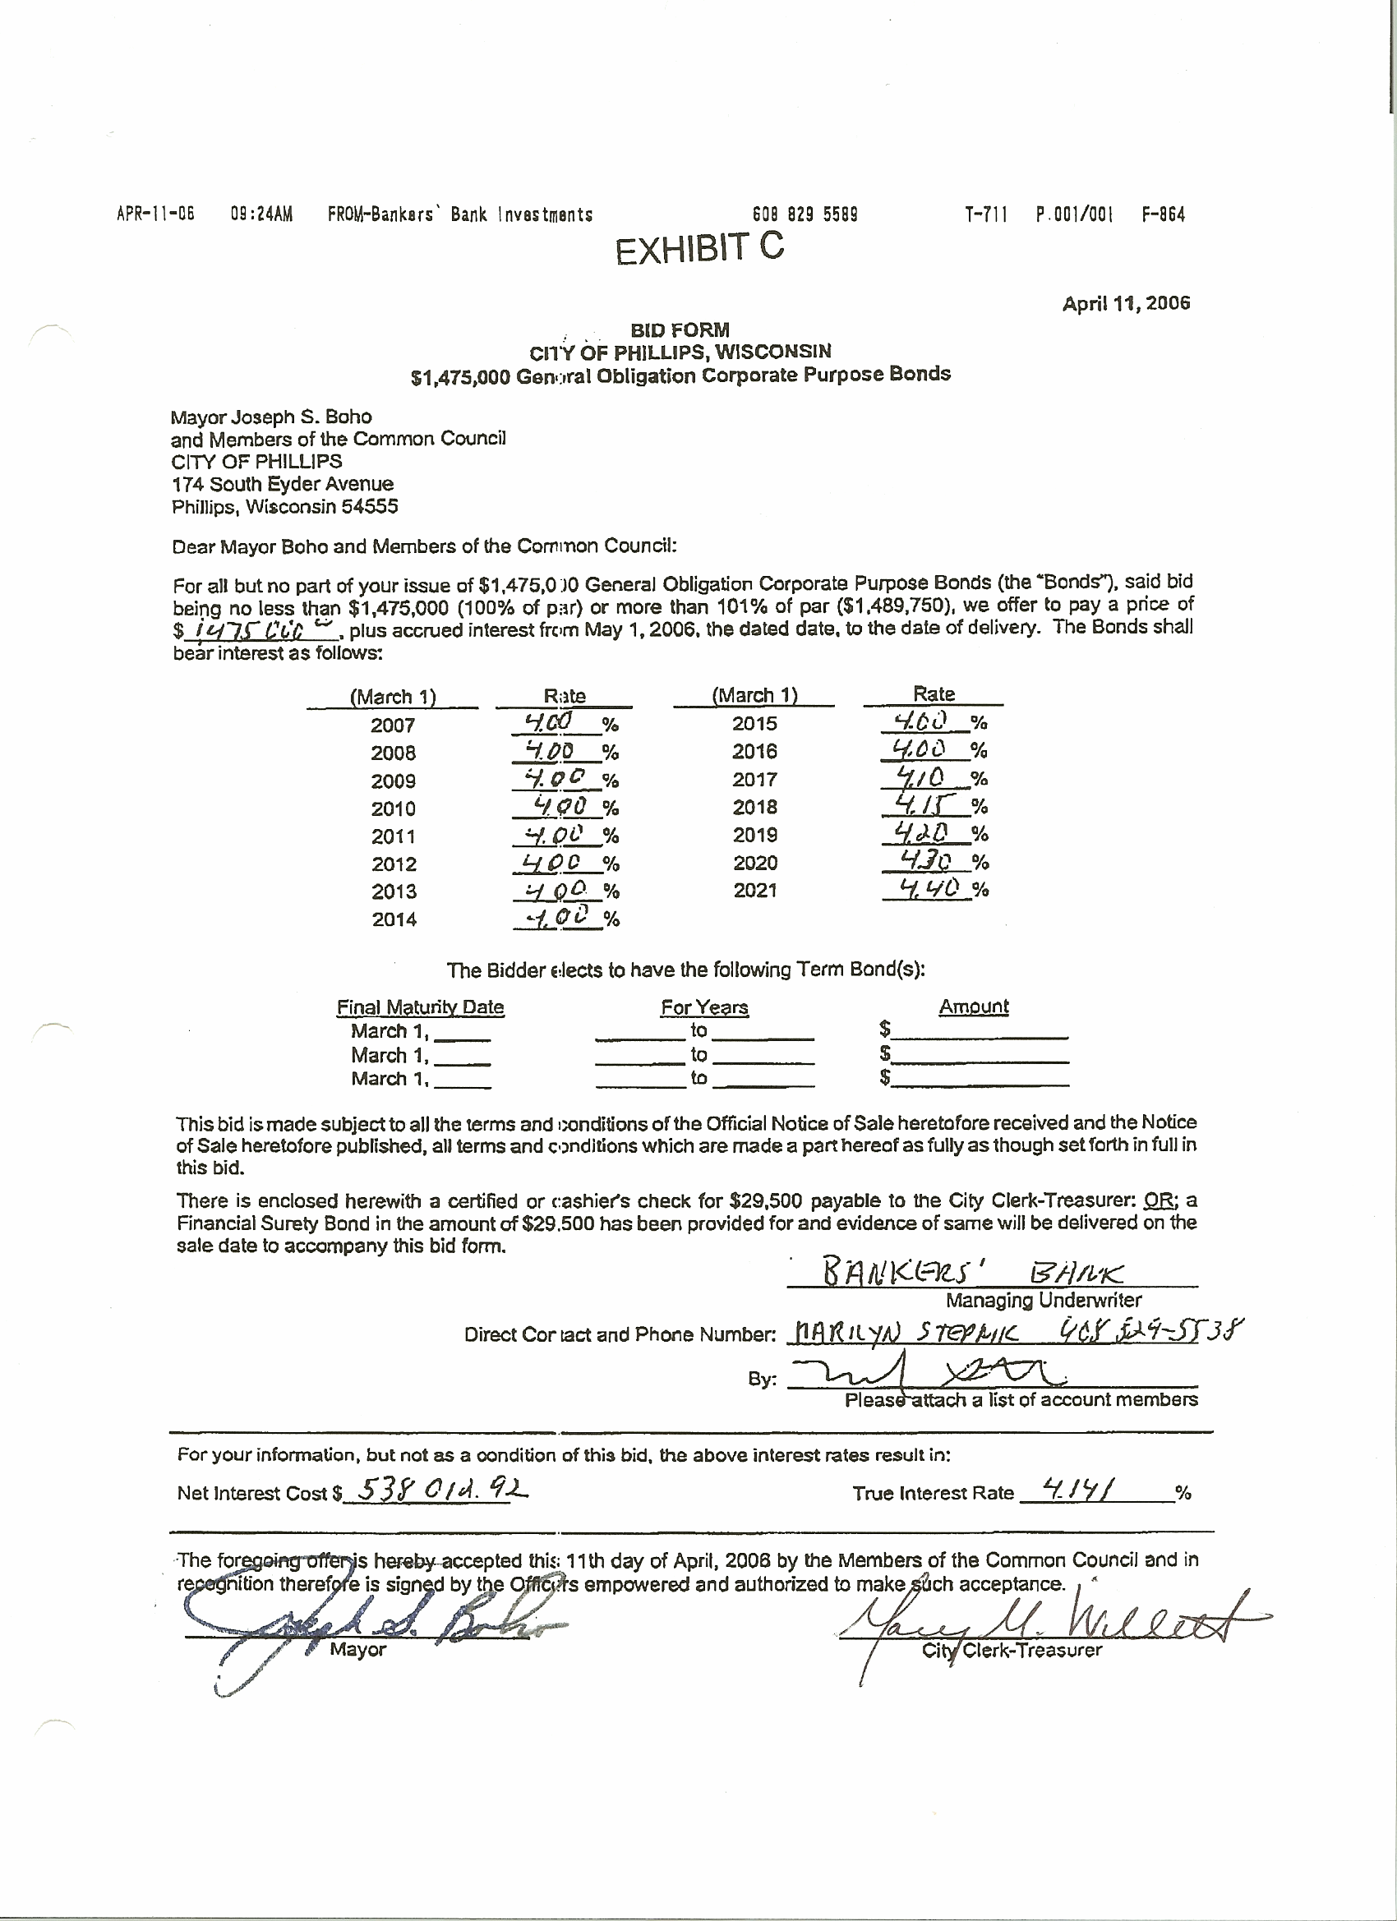
Winning Bid

exhibit D
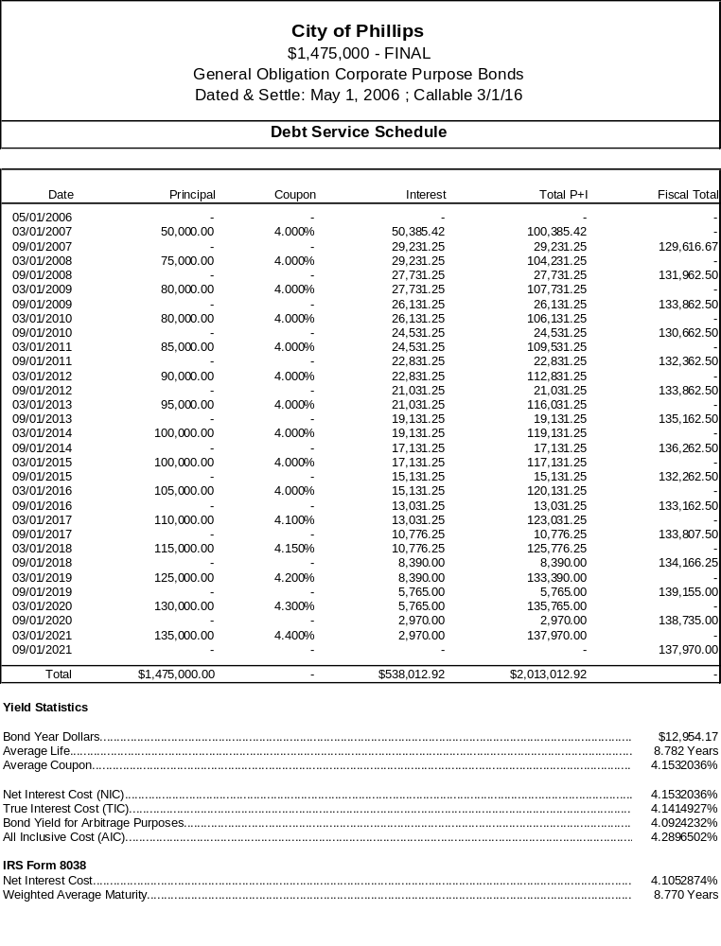

Presley/Chrouser motioned adjournment. Meeting adjourned at 8:37 P.M.

Mary M. Willett
City Clerk-Treasurer

