City of Phillips

Notice of Meeting of the Board of Public Works

Municipal Building: in the Council Room

September 7, 2006 at 5:00 PM

Mayor: Jeffrey V. Fahl
Committee members: Linda Johnson, Charles Peterson and Dorothy Hanish
Department Head: Terry L. Staroba
Clerk/Treasurer: Mary M. Willett

This meeting is held in compliance with Wisconsin’s Open Meeting Law, S.S. Chapter 19, Subchapter V. As such it is open to the public.

Following the open session of this meeting, the Board of Public Works will convene into closed session. Authority: Wisconsin State Statute 19.85(1)(e) deliberating or negotiating the purchasing pf public properties, investing pf public funds, or conducting other specified public business, whenever competitive or bargaining reasons require a closed session.

This meeting may constitute a quorum of the Common Council, or other city committees.

- Call to Order (presiding officer).
  - Greeting
  - Certification of Compliance with Open Meeting Law.
  - Pledge of Allegiance.
- Roll Call
Linda Johnson ___ Charles Peterson ___ Dorothy Hanish ___
Mayor Jeffrey V. Fahl ___
- Set next month meeting date and time October 3, 2006 at 5:00 PM
- Public Comment.
- Motion to accept and/or amend minutes of meeting held on August 1, 2006.
- John Martwick – Roof & UV upgrade
- South Lake Avenue/Hwy 13 Crosswalks
- Skate Park fire – insurance/possible actions
- Roundy’s (Copp’s) parking lot and the City alley
- ATV Ordinance progress – Attorney Bruce Marshall – set next meeting
- Elk Lake Pavilion – plans – responses/ fund raising
10. Deer Management Plan process
- Invoice review
- John Iverson: Argyle Construction Project
- DOT update re: Hwy 13 Access to North Business Park
- Department Updates/Department Budget
- Convene into closed session. Authority: Wisconsin State Statute 19.85(1)(e).
Linda Johnson___Charles Peterson___Dorothy Hanish___
- Reconvene into open session. Wisconsin State Statute 19.85(2).
Linda Johnson___Charles Peterson___Dorothy Hanish___.
16. Action on the subject matter of the closed session.
17. Adjournment
Meeting Minutes
Board of Public Works
September 7, 2006

Chair Linda Johnson called the meeting to order at 5:04 P.M. Present at the meeting: Chuck Peterson, Dorothy Hanish, Mayor Jeffrey Fahl, City Attorney Bruce Marshall, Terry Staroba, John Martwick, John Iverson, and Clerk Mary Willett.

A letter was read by Clerk Mary Willett from Rob Moon – Up North Properties:

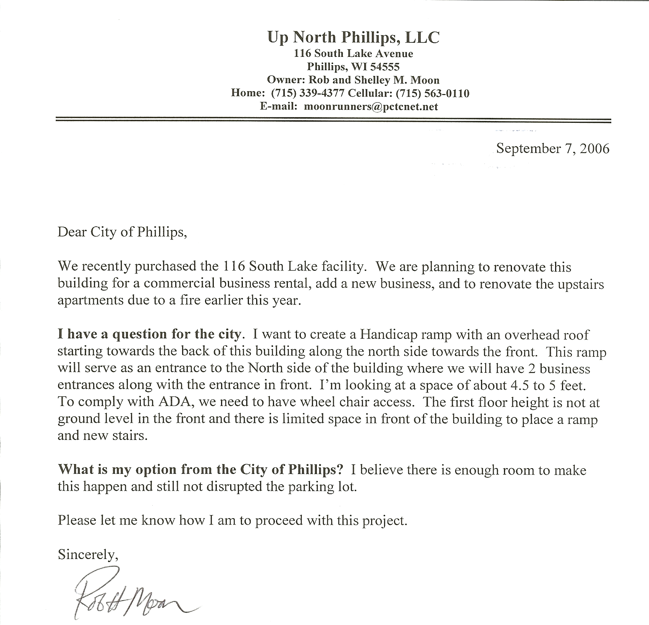

The City will work cooperatively with the Moons for handicapped access in the sidewalk space on the front of the building.

John Martwick reported that the air handling unit was removed from the roof today. New roof is going on Tuesday. The UV unit will arrive October 15th. The City does not chlorinate after October 1st.

John announced his intent to retire in 2007. He plans to work 2 days a week in April and 1 day a week in May and be completely retired by June 1, 2007. John will update the job description immediately with the City Attorney and Terry Staroba so the job replacement process can commence.

Peterson/Hanish motioned to direct Public Works Director Terry Staroba to apply for a permit with Wisconsin DOT for an additional crosswalk on Highway 13 South near the intersections with Avon and Peterson Drive. Carried.

The City’s property insurance through the State of Wisconsin has agreed to pick up the claim for the skate park damage caused by the fire. Unbeknownst to Clerk Willett, the skate park had never been added to the City’s policy. It will be added with the updates due to the State in October.

Bruce Marshall reported that ATV ordinance information will be ready for the working session to be conducted during the October 3rd BPW meeting. He has received the ATV power point that Willett sent to him from the DNR, and he has been receiving updated information from the City of Park Falls regarding changes intended to the ordinance being used as a model for Phillips’.

Clerk Willett shared the letter to be sent requesting partnerships and shared funding opportunities to likely groups. Preparations to send the letter with a color schematic drawing of the pavilion will proceed.

The Deer Management Plan working session is set for 6:00 P.M. on Tuesday September 26, 2006 in the Council Room at Municipal Hall.

John Iverson noted the changes he made to Switlick’s pay request #3. Hanish/Peterson motioned to accept the change orders as presented by John Iverson – 12 in all. Carried.

Peterson/Hanish motioned to recommend payment of the Argyle Street Project bill -Switlick’s #3 pay request - of $300,908.99 with the corrections added by Engineer John Iverson. Carried.

John Iverson reported that the Argyle Street Project is going particularly well. Next Tuesday the crew should be staking for the curb and gutter. Wednesday the strings will be placed and Thursday and Friday the curb and gutter should be poured – the next week at the latest.

Jon Iverson and Ayres will follow up with the DOT personnel who have received the information from Clerk Willett regarding the North Business Park access. Mark Ratty is the DOT connection for the access approval out of Rhinelander.

Terry Staroba reported that the fill between Takco and Compumold is done. The fill by Ken’s Carpet and between Marschke and Dynamo are all from the Street project. All fill is going to areas in the City of Phillips.

Attorney Bruce Marshall presented the Release that will be used by Public Works Director when the parking lot and alley are resurfaced at Copps grocery store. The release follows:

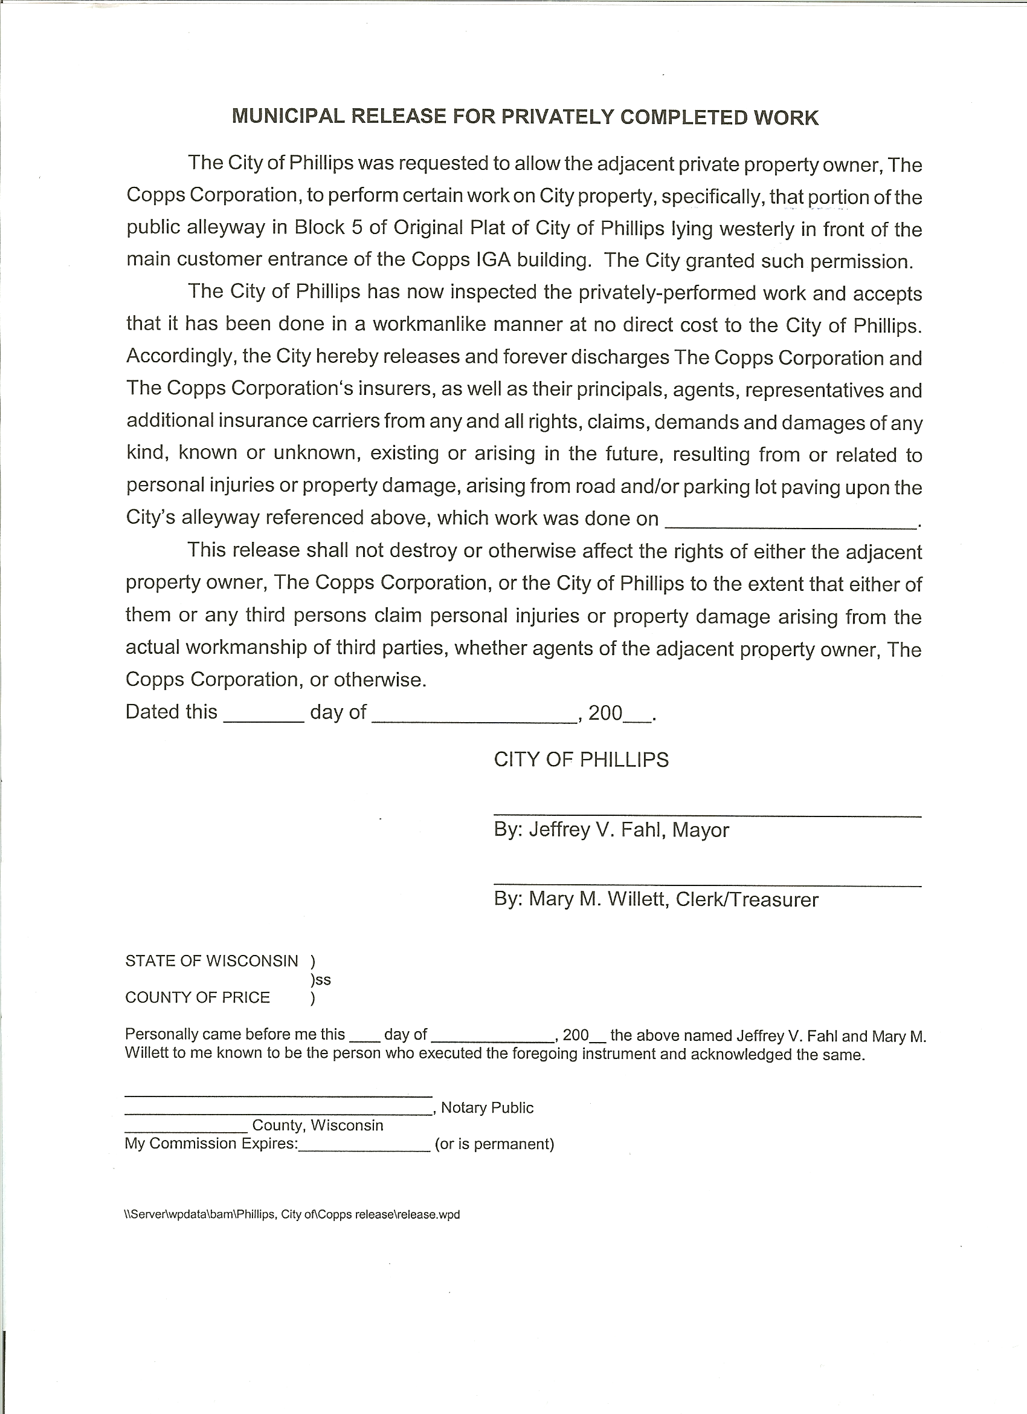
Hanish/Peterson motioned to go into closed session. Carried on a voice vote: Linda Johnson, Aye; Charles Peterson, Aye; Dorothy Hanish, Aye.

Peterson/Hanish motioned to reconvene into open session. Carried on a voice vote: Linda Johnson, Aye; Charles Peterson, Aye; Dorothy Hanish, Aye.

Peterson/Hanish motioned to adjourn. Carried. Meeting adjourned at 6:39 P.M.

Mary M. Willett
City Clerk-Treasurer

