AMENDED – 7/8/11
City of Phillips’ Common Council Meeting
Council Room, Municipal Hall
174 S Eyder Avenue
July 12, 2011
6:00 p.m.
Mayor, Jeffrey V. Fahl
Council Members: Wards 1 & 2 -Jayson Reinke, Laddy Hlavacek; Wards 3 & 4 - Linda Johnson, Charles Peterson; Ward 5 -Dorothy Hanish, Scott Holoubek.
Public Works – Bronson Thalacker; Police – David Sonntag; Library – Rebecca Smith
Clerk/Treasurer: Barb Revak

This meeting is held in compliance with Wisconsin’s Open Meeting Law, WI § Chapter 19, Subchapter V. As such it is open to the public.

Call to Order (presiding officer)
- Greeting
- Certification of compliance with Open Meeting Law
- Pledge of Allegiance

Roll Call: Jeffrey Fahl ___, Laddy Hlavacek___ , Jayson Reinke ___, Linda Johnson, ___ Charles Peterson ___, Dorothy Hanish ___, Scott Holoubek___.

Public Comment

DISCUSSION-ACTION ITEMS:

- Motion to Approve/Correct June 15, 2011 Council Meeting Minutes.
- Motion to approve the payment of vouchers in total amount of $151,170.53.
- Award Presentation – Sherriff’s Department.
- Presentation of 2010 Budget by Eagle Audit & Accounting, LLC.
- Motion to adopt resolution #1126 option 1 redistricting as recommended by the Committee of the Whole.
- Motion to accept the Campground grant application with a change of in kind work and donations being accepted as recommended by the Committee of the Whole.
- Motion to fund the 50% City share from the Recreation fund and a local financial institute if the grant is awarded as recommended by the Committee of the Whole.
- Motion to approve proceeding with signing the paper work for ordering and leasing the new fire truck and temporarily using compressor funds as recommended by the Committee of the Whole.
- Motion to accept Lessee’s Authorization Resolution #1127.
- 2011 budget discussions.
- Committee Reports: Ambulance, Library, Chamber and Economic Development.
- Adjournment
July 12 , 2011
COUNCIL PROCEEDINGS
………of the Common Council of the City of Phillips at a regular meeting held in the Council Room of Municipal Hall on July 12, 2011.
The meeting was called to order by Mayor Fahl at 6:00 p.m. Those present included:
1st Aldermanic District: Laddy Hlavacek and Jayson Reinke
2nd Aldermanic District: Linda Johnson and Charles Peterson
3rd Aldermanic District: Dorothy Hanish and Scott Holoubek
Clerk/Treasurer: Barb Revak

Also present: Becky Smith, Stephanie Daniels, David Sonntag, Kevin Rose and family, Lynn Lutz, Rob Biller, Rev Markal, Jim Pisca, Bronson Thalacker, Brian Schmidt and Mike Hauschild.

Public Comment: NONE

- Hlavacek/Johnson motioned to Approve/Correct June 15, 2011 Council Meeting Minutes. Carried
- Hlavacek/Hanish motioned to approve the payment of vouchers in total amount of $151,170.53. Carried
- Award Presentation: Price County Sherriff presented Officer Rose with a Certificate of Achievement award for entering a burning building and saving a man’s life. A special council meeting will be held on July 26th on a similar matter.
- Johnson/Peterson motioned to accept the 2010 Audit report as presented by Eagle Audit & Accounting, LLC. Carried
- Reinke/Peterson motioned to adopt resolution #1126 option 1 redistricting as recommended by the Committee of the Whole.
RESOLUTION ESTABLISHING MUNICIPAL WARDS

RESOLUTION # 1126

WHEREAS, the City of Phillips is required to establish wards in accordance with Section 5.15 of the Wisconsin Statutes; and,

WHEREAS, it is necessary to reflect the Price County Tentative Supervisory District Plan in the wards so established.

NOW THERE FORE BE IT RESOLVED that the City of Phillips does hereby create a ward plan consisting of 4 wards, as follows:

Ward 1, containing a 2010 population of 399, and comprising a part of tentative supervisory district #13.

A description of the boundaries of Ward 1 consistent with the conventions set forth in Section 4.003 of the Wisconsin Statutes is set forth as follows:
The northern part of the City of Phillips; everything lying north of Flambeau Ave running easterly to the intersection of Kimball St, everything lying west of Kimball St to intersection of Ash St, everything lying north of Ash St running east to the intersection of Fifield St, everything lying west of Fifield St running northerly to Lake Ave, everything lying north of Lake Ave running southerly to the intersection of County Rd H, everything lying west of County Rd H running northerly to bridge; and everything lying westerly, northerly and easterly of Lake Duroy, except that part lying south of Flambeau Ave at the intersection of Flambeau Ave and Storms Rd.

The poling place for Ward 1 is hereby designated as follows: Phillips Municipal Center.

Ward 2, containing a 2010 population of 114, and comprising a part of tentative supervisory district #11.

A description of the boundaries of Ward 2 consistent with the conventions set forth in Section 4.003 of the Wisconsin Statutes is set forth as follows:
Everything lying northerly of Flambeau Ave and easterly of Kimball St, everything lying south of Ash St running easterly to the intersection of Fifield St, everything lying easterly of Fifield St running northerly to Lake Ave, all that part lying south of Lake Ave running southerly to the intersection of Wyoming St, everything lying west of Wyoming St running southerly to the intersection of Flambeau Ave.

The poling place for Ward 2 is hereby designated as follows: Phillips Municipal Center.

Ward 3, containing a 2010 population of 488, and comprising a part of tentative supervisory district #11.

A description of the boundaries of Ward 3 consistent with the conventions set forth in Section 4.003 of the Wisconsin Statutes is set forth as follows:
The southwestern part of the City of Phillips; everything lying south of Flambeau Ave running in a easterly direction to the intersection of Wyoming St running north, everything lying easterly of Wyoming St to the intersection of Lake Ave running southerly, everything lying southerly of Lake Ave to the intersection of County Rd H running northerly, everything lying southeasterly of County Rd H to the intersection of Depot Rd running southerly, everything lying southwesterly of Depot Rd to the intersection of Lake Ave running southerly, everything lying southwesterly of Lake Ave to the intersection of Maple St running southwesterly, everything lying northerly of Maple St to the intersection of Eyder Ave running in a southeasterly direction, everything lying southwesterly of Eyder Ave to the intersection of Pine St running in a northeasterly direction, everything lying southeasterly of Pine St to the intersection of Argyle Ave running southeasterly, everything lying southwesterly of Argyle Ave to Lake Ave running south, and everything lying westerly of Lake Ave, except that part lying south of Flambeau at the intersection of Flambeau Ave and Highway 100.

The poling place for Ward 3 is hereby designated as follows: Phillips Municipal Center.

Ward 4, containing a 2010 population of 479, and comprising a part of tentative supervisory district #11.

A description of the boundaries of Ward 4 consistent with the conventions set forth in Section 4.003 of the Wisconsin Statutes is set forth as follows:
The southeastern part of the City of Phillips; everything lying west and south of Lake Duroy and east of County Rd H running southerly to the intersection of Depot Rd, everything lying northeasterly of Depot Rd running southeasterly to the intersection of Lake Ave running southeasterly, everything lying northeasterly of Lake Ave to the intersection of Maple St running southwesterly, everything lying southeasterly of Maple St to the intersection of Eyder Ave running southeasterly, everything lying northeasterly of Eyder Ave to the intersection of Pine St running northeasterly, everything lying northwesterly of Pine St to the intersection of Argyle Ave running in a southeasterly direction, everything lying northeasterly of Argyle Ave running southeasterly to Lake Ave running south, and everything lying east of Lake Ave.

The poling place for Ward 4 is hereby designated as follows: Phillips Municipal Center.

BE IT FURTHER RESOLVED the there is attached to and made a part of this resolution a map of the City of Phillips which illustrates the revised boundaries of the above-listed wards.

Dated this 12th day of July, 2011

Jeffrey Fahl
Phillips Mayor

I, Clerk in and for the City of Phillips hereby certify that the foregoing is true and correct copy of Resolution No. 1126 adopted by the City of Phillips on the 12th day of July, 2011.

Barbara D. Revak, Phillips Clerk

- Johnson/Peterson motioned to accept the Campground grant application with a change of in kind work and donations being accepted as recommended by the Committee of the Whole. 5-1 vote carried with Holoubek apposing
- Johnson/Hanish motioned to fund the 50% City share from the Recreation fund and a local financial institute if the grant is awarded as recommended by the Committee of the Whole. 4-2 vote carried with Hlavacek and Holoubek apposing
- Johnson/Reinke motioned to approve proceeding with signing the paper work for ordering and leasing the new fire truck and temporarily using compressor funds as recommended by the Committee of the Whole. Carried
- Reinke/Johnson motioned to accept Lessee’s Authorization Resolution #1127. Carried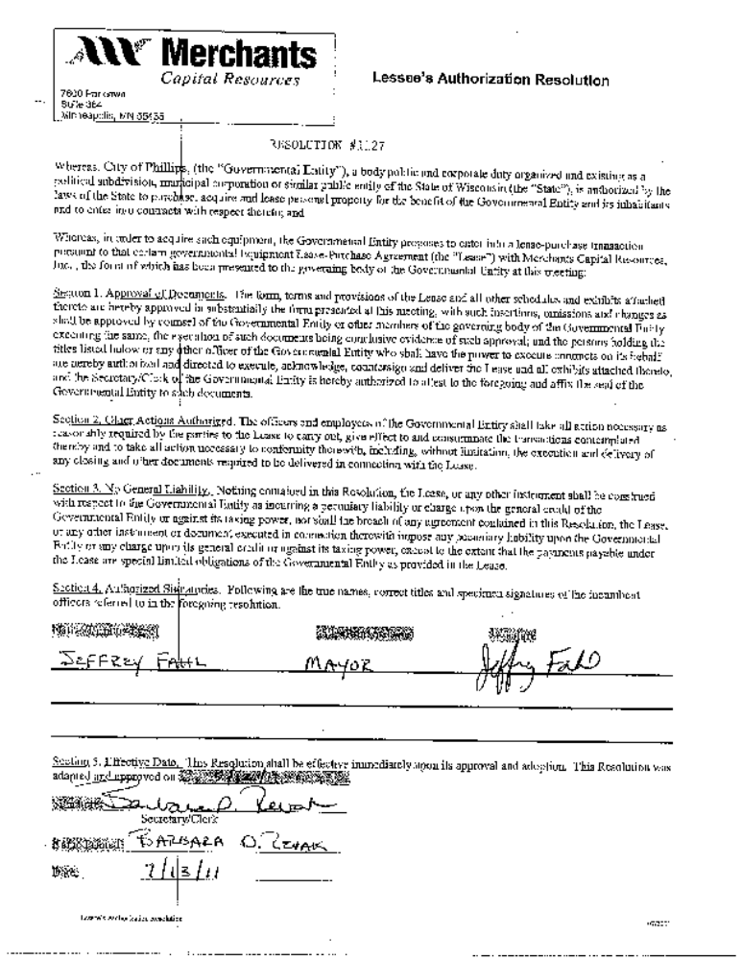
- 2011 budget discussions. For the most part we are in line with the Budget.
Committee Reports:
Ambulance: Sold brats in front of Ross’s Sport Shop and a gentlemen stopped to see what they were doing and it turned out he was from Aspirus and between Aspirus and the Medford Hospital ended with a donation of $10,000 to buy the cot’s that were needed.
Library: Losing an employee and they are going to try to utilize the others instead of hiring a replacement. Summer program is going good. There is going to be a fund raiser “Cork and Pork at Boss Man’s.
Chamber: Wrapped up the 4th of July. The food vendor showed up on the wrong day. Country Side Artist don’t have enough people to run it for more than one day.
PCEDA/IDC: Web site has been update and can get there through the city web site.

Meeting adjourned at 6:53 p.m.

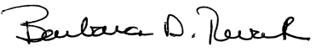
City Clerk-Treasurer

